PROPOSAL OF LIBRARY BUILDING CONSTRUCTION IN SHREE SITA TANDHERI SANSKRIT HIGHER SECONDARY, INDRAWATI-03, SINDUPALCHOWK
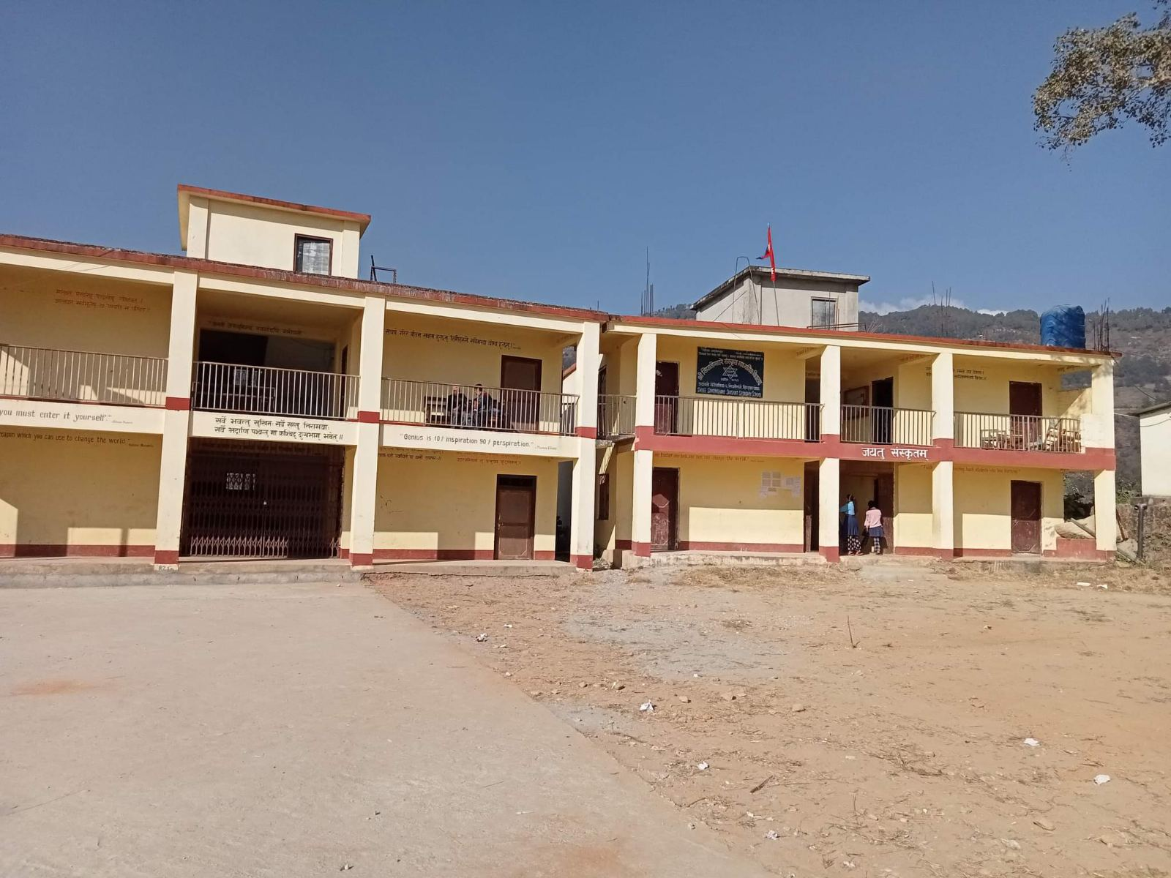
Submitted to: HeNN Australia
Submitted by: Help Nepal Network, Nepal

Background: Shree Sita Tandheri Sanskrit Higher Secondary School is a government school established in 1960 B.S. It is located in Indrawati Rural Municipality-03, Sindupalchok. There are approximately 200 students currently enrolled in the school.
Introduction:
A library in schools is a crucial part for both teachers and students. In this school, there used to be a traditional library which was not properly functioned and maintained which led to a complete removal of library. The number students have decreased in the school because of no library facility for the students. Some of the parents even shifted their children by getting more attracted to other school which provides more facilities. The enrolled students are also looking for a learning hub where they can absorb the required information and knowledge for their study purpose. The school particularly is facing problem to provide a well furnished library room. Therefore, the school is in urgent need for a library building which they are planning to turn into a digital library that can contribute in one solution toward quality education for the children. This project will also help to promote and preserve a government school by adding required facilities.

Objective of the project
- Construct a well furnished library building in the school premises
- Promote government schools facilities for students
- Provide quality education by creating a common and interactive learning room for the students.

Expected Outcomes:
- Well furnished library for the students
- Improvement in quality of education
- Increase in the number of new enrollments of students in the school
- A interactive learning hub for the students
Project requirement:
- Library Building Construction

Estimated Budget of the project

S.N. | Particulars | Total
1. | Building construction | 12,00,000
 | Total | 12,00,000

The above mentioned budget is the estimated cost that will require to fully constructing the library building of the school.

Conclusion
Help Nepal Network stands for “Practical Philanthropy” which benefits disadvantaged communities in three working sector i.e. Health, Education and Disaster. The listed project also falls under the education sector of HeNN and aligns with our goals in education. Our support in this project will definitely help to improve the learning environment and provide quality education to the students. After a thorough discussion between the HeNN Team and the local partner, the proposal was accepted to forward it to HeNN Australia; we reviewed all the factual documents received from the local partner which reflects the genuine and urgent need of library in the school. The HeNN team discussed and found the project reliable to support. In regard to this, we humbly request the generous donor for their kind attention in this mentioned project.

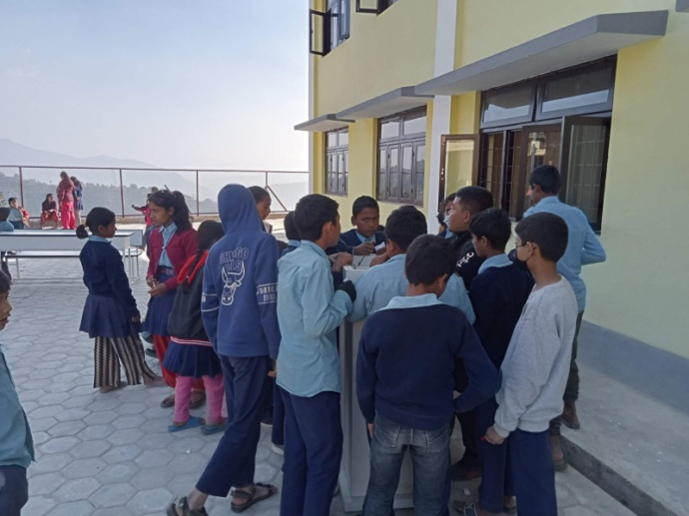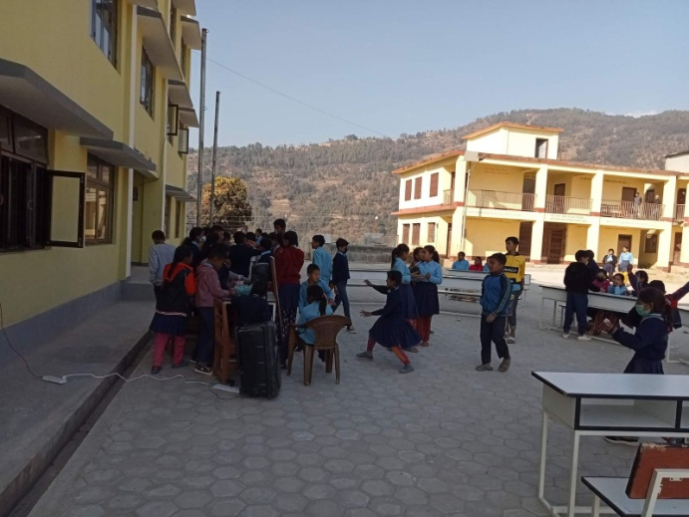
Students engaged in extracurricular activities

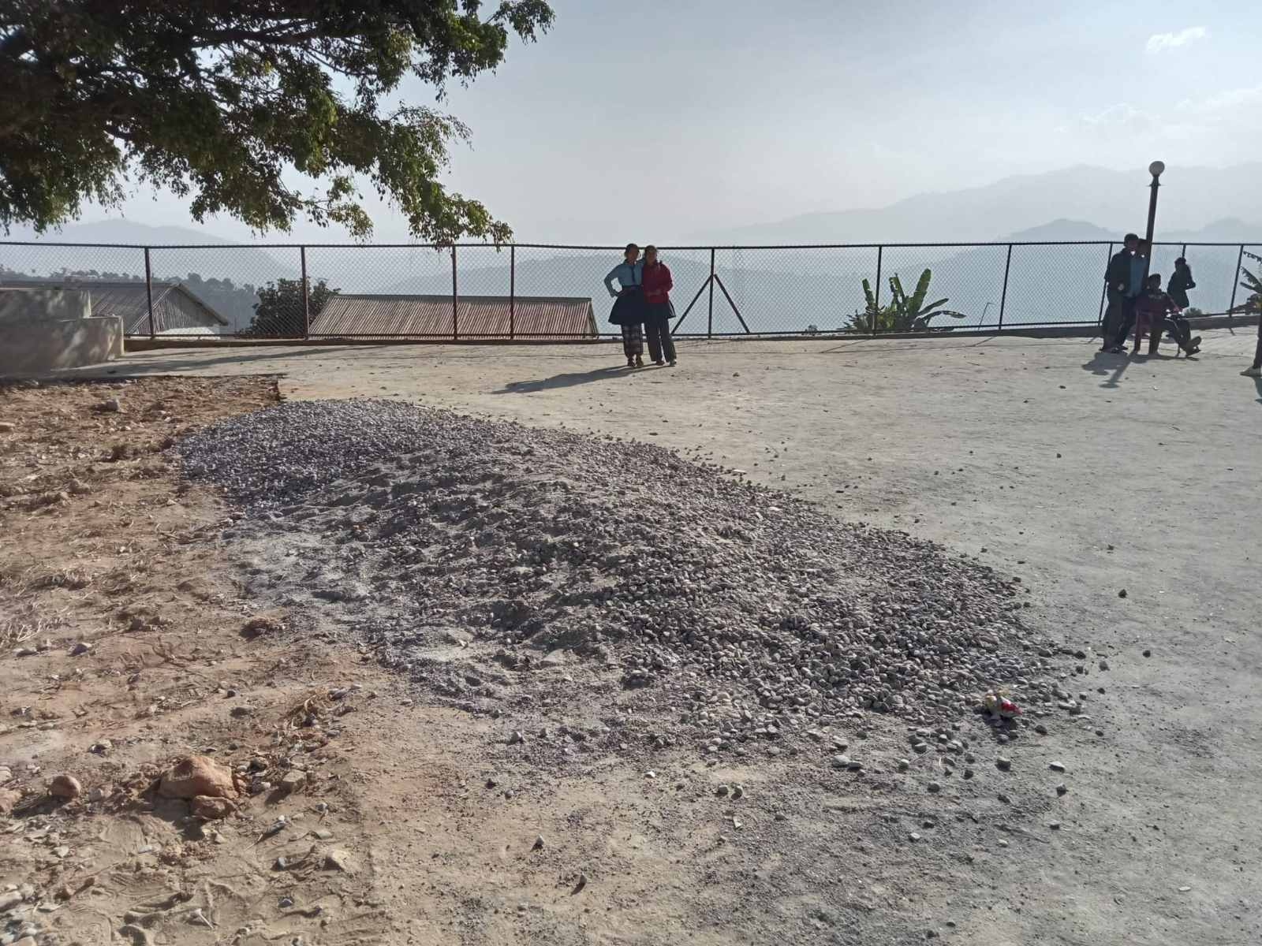
Project site

